**Problem Set 2: Report**

Task 1

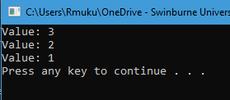

Figure 1: Output for Task 1

The iterator reads through all the 3 linked list nodes and the for loop outputs their values in the console.

Task 2

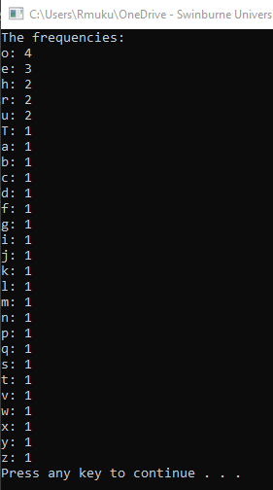

Figure 2: Output for Task 2

Among the algorithms available, the selection sort algorithm is chosen for this task. The algorithm first marks the first index as an “i” value, then it determines the maximum value (in this case, the character with the most frequencies). Once that is done, the position of the maximum value and the marked index will swap. After that, the “i” value is incremented by 1, which would be the second position and the whole process repeats itself until it has read through all the values.

Task 3

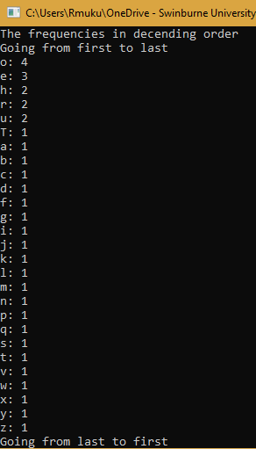

Figure 3: Output for Task 3 (pt1)

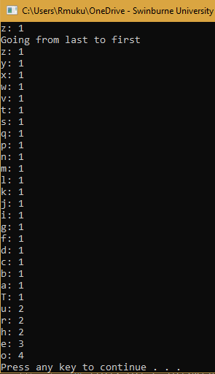

Figure 4: Output for Task 3 (pt2)

For the bidirectional iterator, an -- operator was added to change the position of the index backwards in conjunction to the previous task. This allows the iterator to read characters from the last position to the first position. The changes made in the SortedCharacterCounterIterator header file and cpp file were the additions of -- operators. In the main file, another for loop to read characters from back to front was added after the first loop (reading forwards to backwards). However, there were minor additions to process which are explained in the comments of the main file.